Alpha - Version
User Experience Template
Project Overview
Project Manager: Bheka Mbhele
Project: Sand Lab Testing System
Plant: High Chrome Ball Plant
Version: 1.0.0.0
Prepared by: Tsundzukani Martin Nkuna
From Date: 2025/ 11/ 17 To Date: 2025/ 11/ 19

Project Objectives: The objective of the project is to allow Users to Register, Login and Manage Sand Lab Test Records

Table of Contents
INTRODUCTION 3
BUSINESS RULES 3
1.1 Business Goals: 3
1.2. Business Scope 3
BUSINESS DESIGN CONCEPT 4
2.1 Responsive Design 4
2.2 Responsive Design Principles 4
2.3 Device and Platform Support 4
CORE DESIGN DIAGRAMS 5
3.1 System Design Diagram 5
3.1.1 Sitemap Figure 5
3.2 User Story Design Diagram 6
3.2.1 User-Story Map Figure 6
CORE DESIGN INTERFACES 7
4.1 Wire Frames Design Interface 7
4.1.1 Login High-Fidelity Wire Frame 7
4.1.2 Register High-Fidelity Wire Frame 7
4.1.3 Recover Login Details High-Fidelity Wire Frame 8
4.1.4 Recover Email High-Fidelity Wire Frame 8
4.1.5 Recover Password High-Fidelity Wire Frame 9
4.1.6 Dashboard High-Fidelity Wire Frame 9
4.1.7 Save Sand Test Form High-Fidelity Wire Frame 10
4.1.8 Sand Test Results High-Fidelity Wire Frame 10
BUSINESS DEVELOPMENT CONCEPT 11
5.1 Intended Audience 11
5.2 TimeLine 11
5.3 Resources 11
CONCLUSION 11

INTRODUCTION
This User Experience Template defines the first Design elements of the Sand Lab Testing System – Alpha Version, intended for Development at the High Chrome Ball Plant. Under the guidance of Project Manager Bheka Mbhele and technical ownership by Tsundzukani Martin Nkuna.

BUSINESS RULES

1.1 Business Goals:
The Sand Lab Testing System for the High Chrome Ball Plant is being developed to allow users to register and log in to maintain records of tested sand samples from Line 1, Line 2, and Line 3.

1.2. Business Scope
- Connect to a Ball Forge SQL SERVER AUT-ENG\GM_PRODUCTION to retrieve Sand Test Results that will be automatically stored and be saved using Sand Lab Test System.
- The SQL Server Database stores all Sand Test Results processed through the Sand Lab Test System.
- The data accuracy, that is recorded through the Sand Lab Test System and Database is dependent on the end-user’s standardization.
- Duplicate entries for the same Lines, date, and time must be filtered in the final application report.
- The application will have Access limitations.
  - Registration – Users will be required to register first with work domain email @magotteuaxgmsa.com
  - Login – Only Registered User on the App will be granted access to Login
  - Forgot Email and Password – only Registered Users can recover their login details.
  - Any Employee of Magotteaux GMSA with access to their email address will be given permission to access the application.
- End-User standard dashboard will save, view, export to excel, filter results and Generate Reports.
- Admin dashboard will save, update, view, export to excel, filter results and Generate Reports.
- The report can be extracted into excel format, for further processing
- Sand Test Results records must include both date and time stamps for traceability.
- Entries older than 5 years may be archived but not deleted
- The system must be accessible during standard plant operating hours (24/7), with scheduled downtime communicated 24 hours in advance.
- Automatic backups of all Sand Test Results data must occur every 24 hours.

BUSINESS DESIGN CONCEPT

2.1 Responsive Design
The Sand Lab Testing System will be developed using a fully responsive design approach to ensure a consistent, user-friendly experience across all supported devices. The interface will automatically adapt to various screen sizes and resolutions without compromising functionality.

2.2 Responsive Design Principles
- Adaptive Components
UI components will scale proportionally to maintain readability and functionality on both large and small screens.
- Mobile-First Approach
The interface will be designed with mobile/tablet constraints first and progressively enhanced for larger screens
- Consistent Navigation
Navigation menus will adapt into collapsible or slide-out formats on smaller screens while preserving familiar layout structures on desktops.
- Accessibility Compliance
Text contrast, button sizes, spacing, and interaction elements will follow accessibility standards to ensure ease of use

2.3 Device and Platform Support
The responsive design must ensure full functionality and optimal performance on the following devices and platforms used within the plant environment:
- Desktop and Laptop Computers
  - Windows-based systems connected to the network.
- Tablets
  - Must support touch input, responsive tables, and real-time data viewing.
- Supported Browsers
  - Google Chrome (Primary)
  - Microsoft Edge
  - Responsive behaviour must not rely on browser-specific features.

CORE DESIGN DIAGRAMS

3.1 System Design Diagram

3.1.1 Sitemap Figure
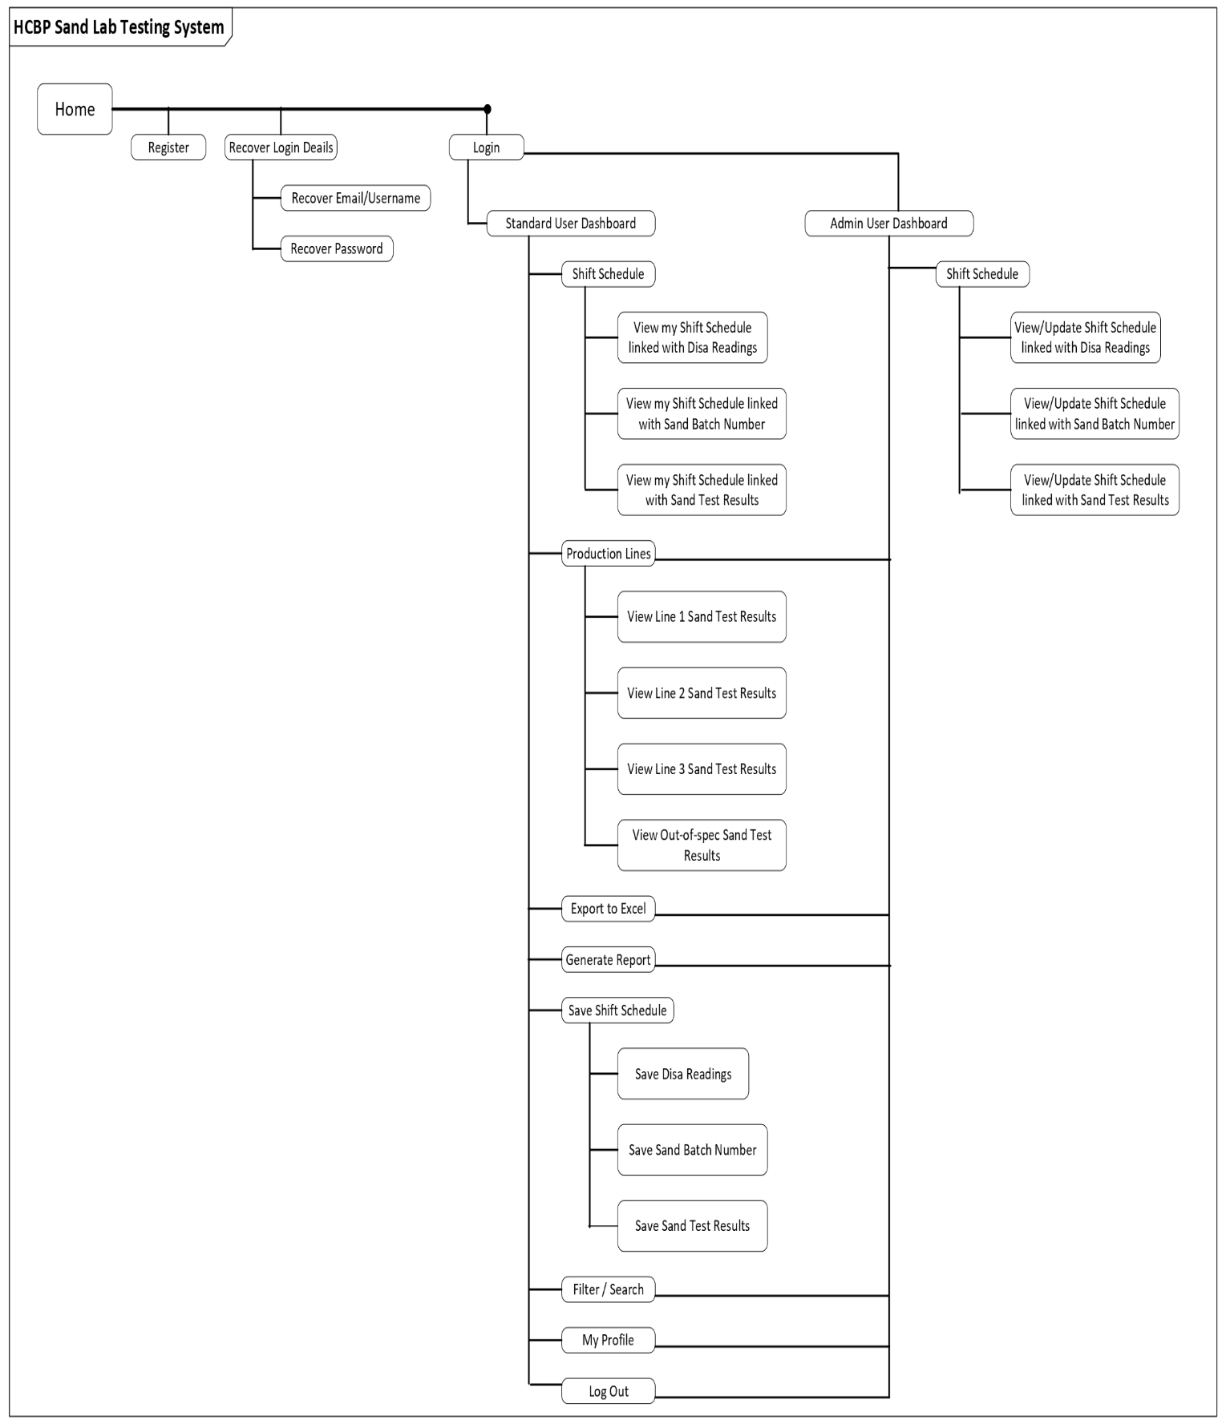

3.2 User Story Design Diagram

3.2.1 User-Story Map Figure

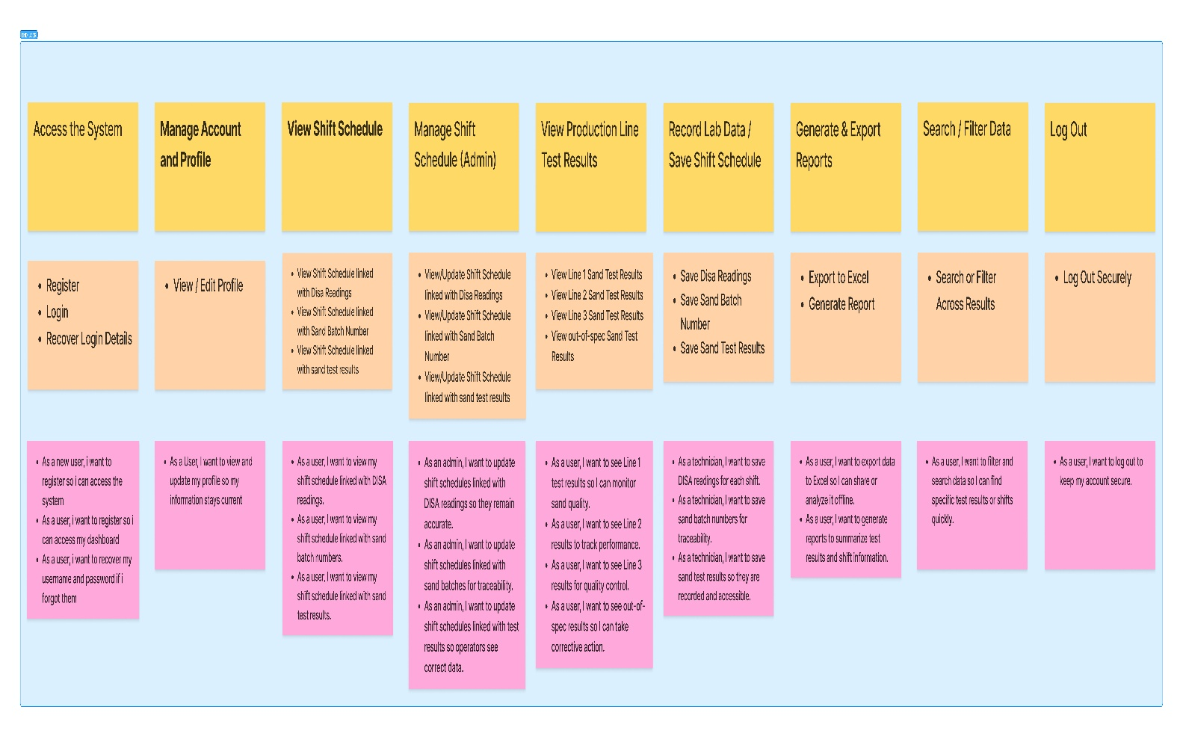

CORE DESIGN INTERFACES

4.1 Wire Frames Design Interface

4.1.1 Login High-Fidelity Wire Frame
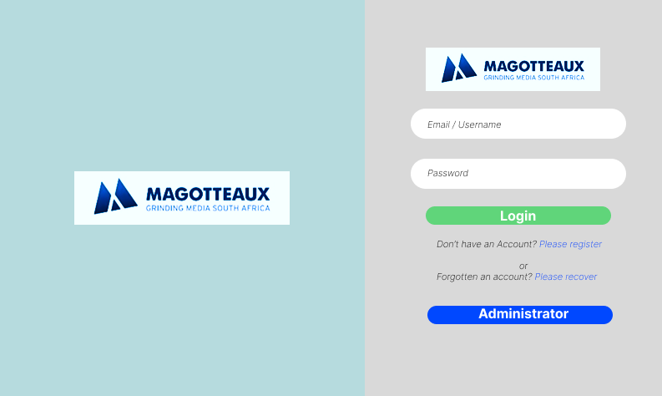

4.1.2 Register High-Fidelity Wire Frame
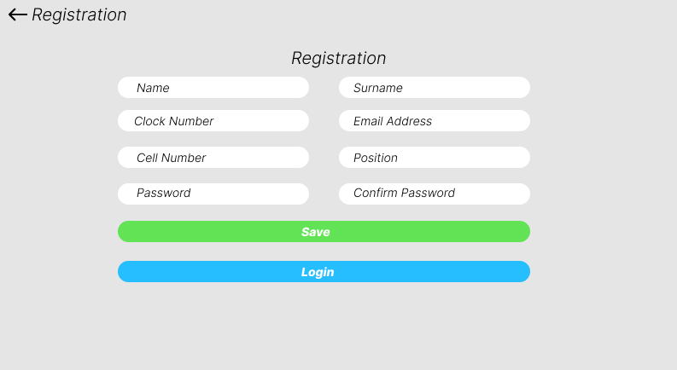

4.1.3 Recover Login Details High-Fidelity Wire Frame
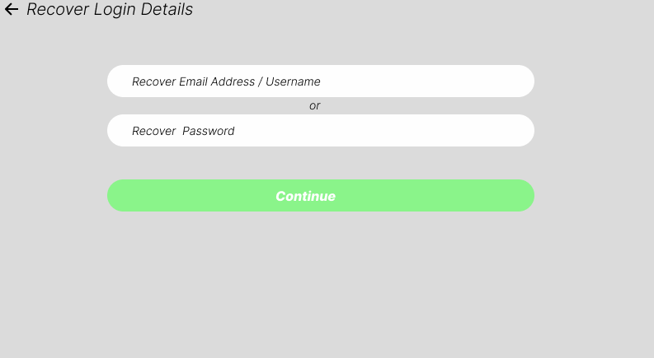

4.1.4 Recover Email High-Fidelity Wire Frame
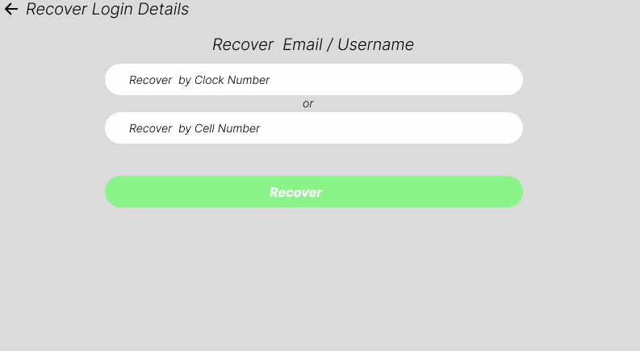

4.1.5 Recover Password High-Fidelity Wire Frame
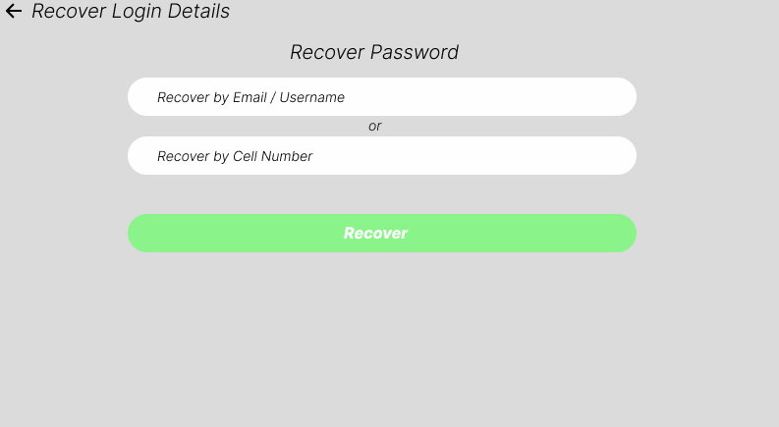

4.1.6 Dashboard High-Fidelity Wire Frame
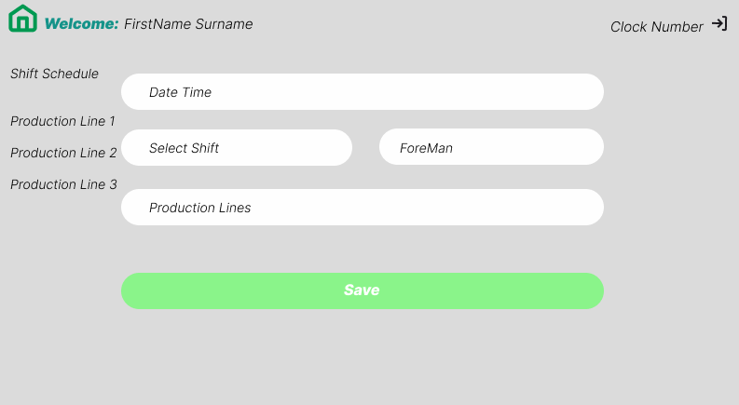

4.1.7 Save Sand Test Form High-Fidelity Wire Frame
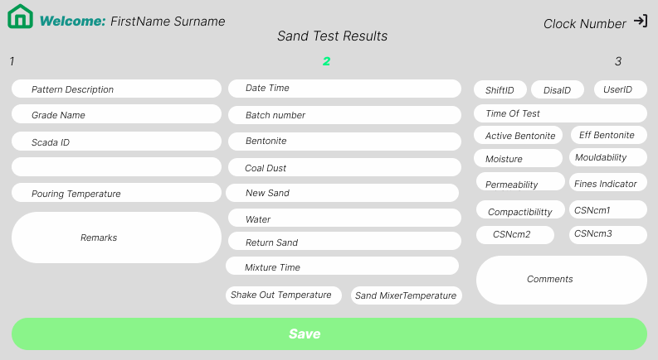

4.1.8 Sand Test Results High-Fidelity Wire Frame
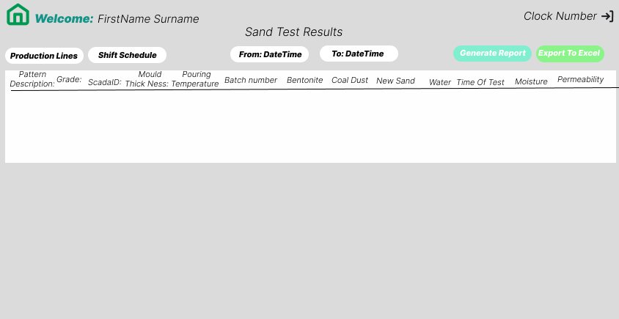

BUSINESS DEVELOPMENT CONCEPT

5.1 Intended Audience
- End -User
  - Standard dashboard Users
  - Admin dashboard Users

5.2 TimeLine
- Development Start: 25th October 2025
- Testing Phase: Frequently after Updates
- Go-Live: Frequently after Updates approval

5.3 Resources
- Team
  - MIS Technician Trainee
- Technology:
  - IIS (Internet Information Services)
  - SQL Server
  - Visual Studio
  - Android Studio

CONCLUSION
This User Experience Alpha version delivers a purpose-built, user-cantered interface for the Sand Lab Test System at the High Chrome Ball Plant—designed to Display real-time monitoring and data traceability.

